# 2018/19 Annual Report

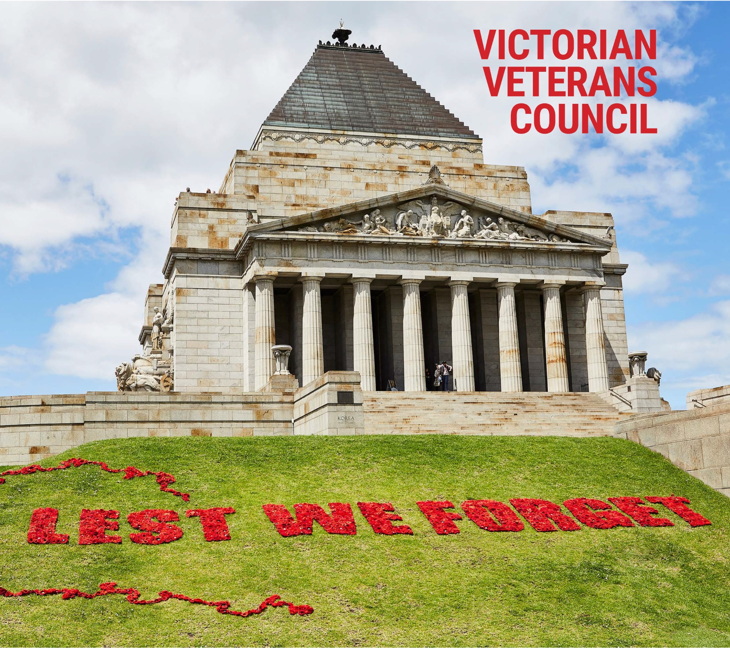



**Cover image supplied by the Shrine of Remembrance Melbourne Photograph by Susan Gordon Brown**

CONTENTS

Chairperson’s Foreword 4

About the Victorian Veteran’s Council 6

Objectives and Functions of the Victorian Veterans Council 7

Members of the Victorian Veterans Council 8

Members of the Victorian Veterans Council 12

Highlights of the Year 14

Corporate Governance 15

Anzac Day Proceeds Fund 16

Victorian Veterans Fund 17

Patriotic Funds 19

## Chairperson’s Foreword

Over the past year the Victorian Veterans Council (VVC) has remained focused to ensure the objectives of the VVC are met. In particular, the VVC has been proactive in seeking opportunities to enhance its profile, so that ultimately, its work is directed towards supporting Victorian veterans and their families; and reporting to the Minister for Veterans on current and emerging issues affecting each generation of our veteran community.

All of this requires a strong obligation and I am grateful to my fellow VVC members for their dedicated support. This year’s report provides examples that demonstrate this obligation and commitment and I am pleased to share the following highlights with you.

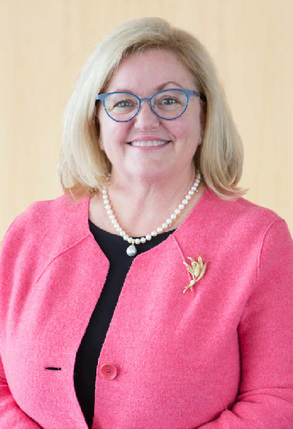

### Collaboration

A key success factor when developing advice for the Minister is effective consultation and collaboration with the ex-service community. In addition to monthly updates from both RSL and Legacy via their representatives on Council, the VVC received a variety of briefings and papers encompassing a number of significant initiatives within the veteran’s community. The VVC acknowledges the vital services and support provided by Victoria’s ex-service community to meet the wide-ranging needs of our veterans. It is a privilege to witness the efforts of these dedicated organisations and to see firsthand the goodwill resulting from their tireless efforts.

### Communication

To remain responsive to issues impacting on veterans and their families, the VVC is reviewing our communications strategy to improve how we can best engage with each generation of veterans. The Council will remain flexible in developing methods to ensure we can more widely communicate with the veteran community into the future.

### Multi-Media Prize

Last year I was pleased to announce that the VVC entered into a partnership with RMIT University to deliver the Victorian ANZAC Tertiary Multimedia Award. The award has been developed to engage tertiary students from across Victoria to explore the ANZAC legacy. This award adds a tertiary-level element to the existing education activities offered to secondary students as part of the Premier’s Spirit of ANZAC Prize. My thanks to Dr Ross Bastiaan and Ms Liz Brown for their continual efforts in developing this initiative.

### Grant Programs

The VVC has specific responsibility for the distribution of the ANZAC Day Proceeds Fund to support a range of welfare activities for veterans and their families. Those activities are detailed later in this report. The VVC also has responsibility for distributing the Victorian Veterans Fund and is committed to supporting education and commemorative events through the Victoria Remembers Minor Grant Program. It is through disbursement of these funds that education and commemoration to honour the service of our veterans continues. A full list of grant recipients is provided in this report.

### Governance

Leveraging from the Australian Institute of Company Directors training program conducted in May 2018, the VVC has strengthened our governance framework with particular focus on risk management. A planning day was conducted in February 2019 to establish a new work plan for the next reporting period; this work plan will attribute activities directly to VVC objectives and include success measures.

### Council Membership

During this year the VVC welcomed three new members to the Council. The appointment of Lieutenant Commander Peta Irving RAN (Rtd) has strengthened Council representation for Navy and female veterans. Mr Bruce Mildenhall’s appointment affords Council an in depth understanding of the Victorian Veterans Act 2005, the legislation that established the Victorian Veterans Council. Mr Geoff Brewer was appointed as the new Melbourne Legacy representative following Lieutenant Colonel Justin Elwin’s departure in November 2018.

The VVC plays an important role in recognising the service, sacrifice and needs of each generation of Victorian veterans and I would like to express my sincere thanks to the many individuals and organisations who work with the VVC and alongside our veterans. Your commitment and dedication to the mutual goal of respecting, honouring and supporting our veterans is highly respected and valued.

Finally, I would like to offer my heartfelt appreciation for the support and guidance my colleagues have afforded me during this year. I look forward to progressing the VVC’s efforts to support and serve each generation of Victoria’s veterans in the coming year.

I am pleased to present the 2018-2019 VVC Annual Report.

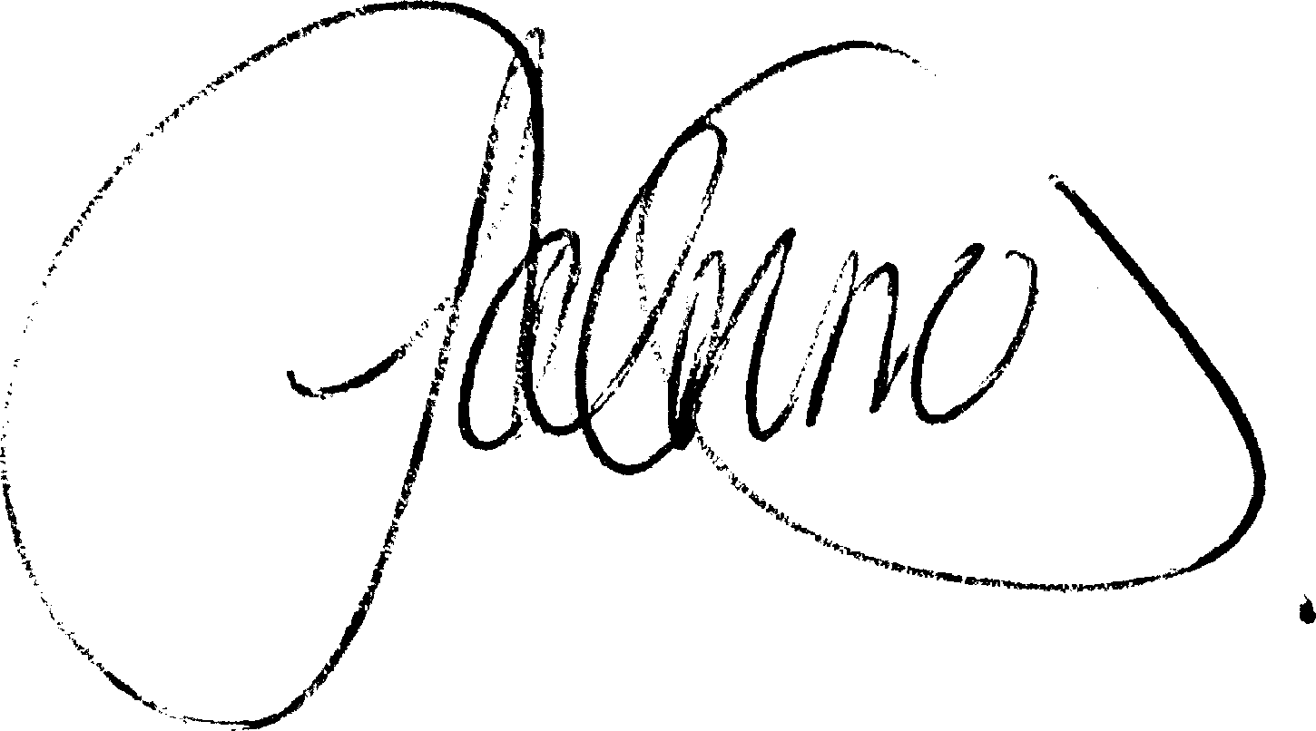

**LAUREEN GRIMES**

**Lieutenant Colonel, Chair**

## About the Victorian Veteran’s Council

The Victorian Veterans Council (VVC) is an independent statutory body established in August 2006 under the Veterans Act 2005 (the Act)

The VVC plays an important role in supporting Victorian veterans and their families and is responsible for reporting to the Minister for Veterans on issues affecting the Victorian veteran community.

Under the Act, the VVC has specific responsibility for the distribution of the ANZAC Day Proceeds Fund and Victorian Veterans Fund. The VVC also assists the government by providing:

* general advice to the Minister for Veterans on issues affecting Victoria’s veterans such as the current and future needs of veterans and their families
* advice to the Director of Consumer Affairs on matters relating to the regulation of patriotic funds
* advice on a range of government programs and initiatives such as, the Premier’s Spirit of Anzac Prize, the Victorian ANZAC Tertiary Multimedia Prize, the Veterans Accommodation Project, the Shrine to Sea Project, and the Victoria Remembers Major Grants Program.

The VVC is supported by the Veterans Branch within the Department of Premier and Cabinet (DPC).

## Objectives and Functions of the Victorian Veterans Council

The objectives and functions of the VVC are detailed in Sections 5 and 6 of the Veterans Act 2005 (the Act).

The objectives of the VVC are to:

* promote the wellbeing of all members of the Victorian ex-service community
* promote the commemoration of those who have died in the performance of service or duty
* develop a better understanding amongst Victorians of the service and sacrifice of Victoria’s veterans in war and peacekeeping operations and the contributions of Victoria’s ex-service community
* actively promote the significance of, and key values associated with, the spirit of Anzac
* promote cooperation and collaboration across organisations dealing with veterans welfare and other ex-service community issues, including the Trustees of the Shrine of Remembrance.

The functions of the VVC are to:

* ensure that the objectives of the VVC are met to the maximum extent that is practicable
* monitor and advise the Minister for Veterans on issues affecting Victoria’s ex-service community
* investigate and report on any aspect of veterans affairs referred to it by the Minister
* consult with the ex-service community when developing advice for the Minister
* support the welfare activities of ex-service organisations through the ANZAC Day Proceeds Fund (in accordance with the ANZAC Day Act 1958)
* fund activities furthering its objectives through the Victorian Veterans Fund (in accordance with Section 20 of the Act)
* advise the Director of Consumer Affairs on matters in relation to the regulation of patriotic funds under Part 4 of the Act.

## Members of the Victorian Veterans Council



### Lieutenant Colonel Laureen Grimes, Chair

(Appointed 18 June 2012, appointed Chair 10 October 2018)

Laureen has been an Army Reservist since 1980 and has attained the rank of Lieutenant Colonel in the Royal Australian Transport Corps. During her career she served in a broad range of roles including Chief of Staff 4th Brigade, Defence Liaison Officer for the Melbourne Commonwealth Games and as Honorary Aide de Camp to the Governor of Victoria for three years. Laureen was appointed Commanding Officer of Victoria’s Combat Support Services Battalion that was closely involved with the 2009 Victorian Bushfire support. She is currently based at Victoria Barracks Melbourne and is serving in a support role with Joint Logistics Command who provide logistics services across the Australian Defence Force.

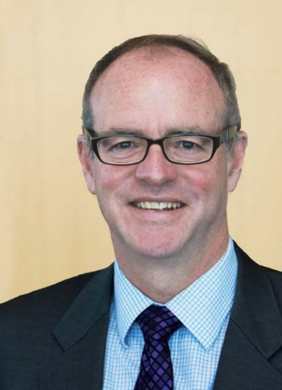

### Brigadier Michael Annett, CSC

(Appointed 19 March 2013, reappointed 30 August 2016)

After graduating from the Royal Military College, Michael was appointed to the 1st Armoured Regiment. From 1988 to 1989 he served with United Nations Iran-Iraq Military Observer Group. Following discharge from the Regular Army in 2006, Michael was appointed CEO of the Victorian Branch of the RSL. In January 2007, he resumed soldiering as a Reservist. In January 2013 Michael was promoted to the rank of Brigadier and assumed the command of the 4th Brigade. In July 2015 he was deployed as the Commander of Task Group Afghanistan. Since returning he has been appointed State Secretary of the Victorian Branch of the RSL. Mike was awarded a Commendation for Distinguished Service in the 2017 Queen’s Birthday Honours List.

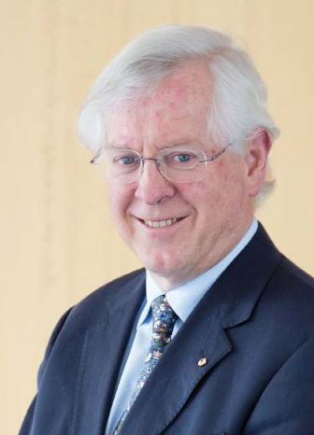

### Dr Ross Bastiaan, AM RFD

(Appointed 1 January 2013, reappointed: 2 February 2016; 26 March 2019)

Ross enlisted in the Army Reserve in 1975 and was attached to 3 Army Field Ambulance. In the Royal Australian Army Dental Corps (Res) he was promoted to Colonel Consultant and is currently attached to Defence Health Services Branch, Canberra. Ross served on the Council of the Australian War Memorial from 1995 to 2009. Since 1990 he has personally placed over 240 multi-lingual, large bronze commemorative plaques at various locations around the world from Europe to the Great Ocean Road in Victoria. He has also written three books on WWI and WWII. Since 1978 Ross has worked in private practice as a periodontist.

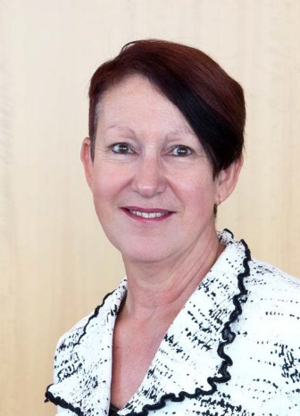

### Wing Commander Sharyn Bolitho Raafar

(Appointed 4 November 2015, reappointed 26 March 2019)

Sharyn Bolitho joined the Royal Australian Air Force in 1987 and during her time in the RAAF she held postings on the staff of the Chief of Defence Force (working for Admiral Chris Barrie at the time of the terrorist attack on 11 September 2001) and was later responsible for joint operational personnel issues relating to deployment in 2002, receiving a Commendation from Commander Australian Theatre. Sharyn was appointed Commanding Officer of Combat Support Unit East Sale in December 2008, transitioning to Commanding Officer No 30 (City of Sale) Squadron when it was reformed 1 July 2010. She left the Permanent Air Force in May 2012 to remain in Sale and accepted an appointment as Manager Economic Development at Wellington Shire Council. Sharyn transitioned back to RAAFAR in 2017 as the East Sale Indigenous Liaison Officer and is now responsible for Heritage and Executive Support.

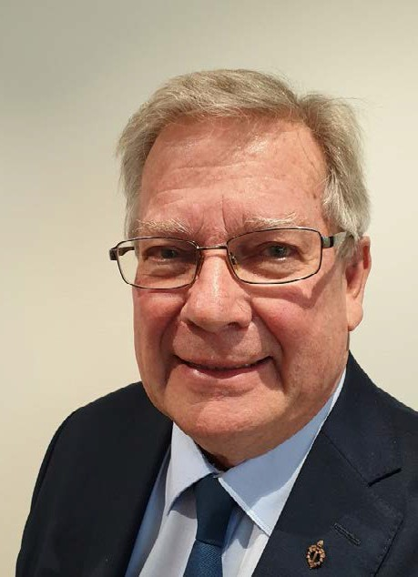

### Mr. Geoffrey Brewer

(Appointed 26 March 2019)

Geoff Brewer completed National Service with 2RAR in 1966-1967, including a tour of duty to Vietnam in 1967 where he served as an infantryman. Following his military service, Geoff returned to his career as a teacher in Victoria. In 1984, Geoff was awarded an International Teaching Fellowship placement at Hoover Middle School in Buffalo, New York. Geoff spent the final 11 years of his teaching career as Principal of Solway Primary School, before retiring in 2000. Geoff has been a longstanding member of Melbourne Legacy, serving as the convenor of the Melbourne Legacy Education Panel for 16 years, and as the Legacy member of the Veterans’ Children Education Scheme Victorian Board since 2001. Geoff is the Legacy member of the Victorian Veterans Council.

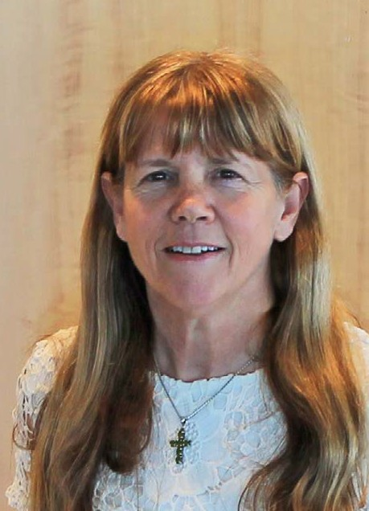

### Ms Elizabeth Brown

(Appointed 30 September 2014, reappointed 6 February 2018)

Elizabeth is a widow of a Vietnam veteran, was a carer to her father-in-law (a WWll veteran) and has been a Pensions/Welfare Officer for the past six years. She has completed a law degree at Victoria University, is a qualified Associate Accountant and has worked in finance roles across government. Elizabeth was nominated for appointment to the Council by, the Vietnam Veterans Association of Australia Victorian Branch (Noble Park Sub-Branch).



### Lieutenant Commander Peta Irving (Rtd)

(Appointed 7 August 2018)

Lieutenant Commander Peta Irving RAN (Rtd) joined the Women’s Royal Australian Naval Service in 1983 after spending four years in the Army Reserve Artillery Corp. Peta joined as a Naval Supply Officer and was one of the first females to serve at sea in a permanent position on the HMAS JERVIS BAY in 1985. While in the Navy Peta was logistics officer for Operation RELEX and specialised in joint IT logistic systems as a Project Manager. Peta’s last position in the Royal Australian Navy was as the National Manager Warehousing for the Department of Defence. Since leaving the Navy, Peta has been teaching and consulting in Project Management and Supply Chain and Logistics, volunteering and travelling the world.

## Members of the Victorian Veterans Council



### Lieutenant Commander Pelagia Markogiannakis

(Appointed 6 February 2018)

Pela has been a Navy Reservist since 1986 and has attained the rank of Lieutenant Commander. She has held a variety of logistics, engineering and infrastructure related roles. Pela is an engineer and certified project professional. She has been the Aide-de-Camp in Waiting to His Excellency the Governor of New South Wales and the His Excellency the Administrator of the Commonwealth of Australia. She is currently serving in a staff role to Shore Force at Fleet Headquarters, Sydney and is the Staff Officer for Reserves in Victoria reporting to the Head of Reserves in Canberra. Pela currently holds the executive infrastructure governance role with Major Road Projects Victoria.



### Ms Kim McAliney

(Appointed 30 August 2016)

Kim was Deputy Mayor for the City of Wyndham from 2016 to 2017. She was first elected in 2005 and previously elected Mayor for 2007 to 2008, and 2011 to 2012. Kim is a Fellow of CPA Australia, has an Advanced Diploma in Public Safety (E.Mgt) and is a Graduate of the Australian Institute of Company Directors (AICD). Kim has worked at accountancy firms, in the aged care and retirement sector, a multinational company and a National Crisis Counselling service and held numerous board directorships. She has been a Trust Member of The Greater Metropolitan Cemeteries Trust since 2013.

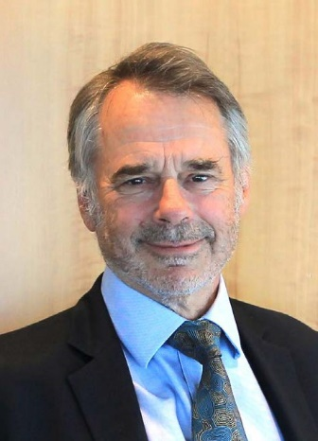

### Mr Bruce Mildenhall

(Appointed 7 August 2018)

Bruce is not a veteran but has broad experience and strong personal interest in the veteran sector. He is currently involved in commemorative activities as Chair of the Mt Macedon ANZAC Dawn Service, and has assisted as support rider in the Vietnam Veteran Vetride. Bruce’s father was a Rat of Tobruk and maternal grandfather an officer in the ANZAC Light Horse. As a former State MP and Parliamentary Secretary for Veterans’ Affairs, Bruce assisted in the drafting of Victoria’s veterans legislation, the Veterans Act 2005, and led the first Premier’s Spirit of Anzac Prize tour to the Western Front.

## Highlights of the Year

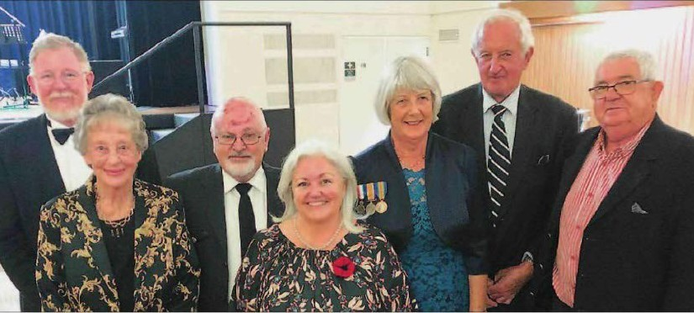

Lieutenant Colonel Laureen Grimes (centre) at the centenary celebrations for the Leongatha Returned & Services League Sub-Branch. Image supplied by the South Gippsland Sentinel Times.

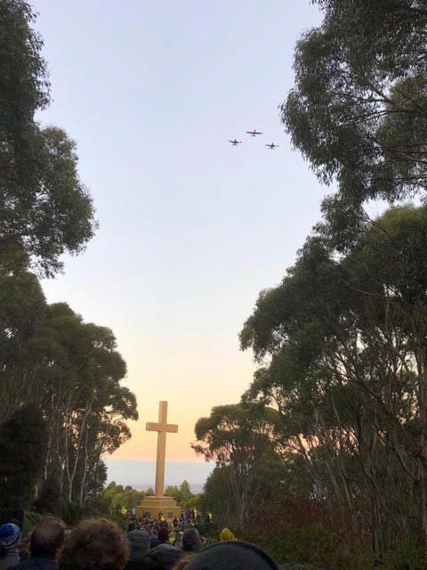

2019 ANZAC Day Dawn Service at the Mount Macedon Memorial Cross.

### Engagement with the Ex Service Community

Throughout the year VVC members have attended events and commemorations to maintain links with Victoria’s ex-service community. In February 2019, VVC Chair LTCOL Laureen Grimes had the opportunity to speak at the centenary celebration of the Leongatha Returned & Services League Sub-Branch (pictured). Other events attended during the year include scholarship award presentations for both the Nurses Memorial Centre and the Albert Coates Memorial Trust which the VVC support as patriotic fund trustees.

### Commemoration and Anzac Day Services

The VVC supports ANZAC Day and other commemorations and events in local communities through the provision of funding from the Victorian Veterans Fund distributed under the Victoria Remembers Minor Grant program. In 2019 support was provided for ANZAC Day Dawn Services held at the Mount Macedon Memorial Cross (pictured), Torquay and Geelong to name a few. Other commemorations supported include the Battle for Australia Ceremony, the Sir Edward ‘Weary’ Dunlop Commemorative Service, Boer War and Vietnam Veterans Day.

## Corporate Governance

### Council Meetings

The Veterans Act 2005 requires that the VVC must meet at least eight times each year. The Council held seven meetings during the period 1 July 2018 to 30 June 2019, with an eighth meeting rescheduled to July 2019.

### Committee Structure

The VVC has established two committees to facilitate the performance of its functions under the Act.

### Funding Sub-Committee

The Funding Sub-Committee is responsible for the development and annual review of the guidelines for the Victorian Veterans Fund Grant Programs and the ANZAC Day Proceeds Fund, coordinating the application process for both funds and making funding recommendations to the VVC for grants from both funds. Dr Ross Bastiaan is the current Chair of the Funding Sub- Committee. The other members of the Sub-Committee are Wing Commander Sharyn Bolitho, Ms Elizabeth Brown, Lieutenant Commander Peta Irving (Rtd) and Mr Geoffrey Brewer. The Committee met on two occasions throughout the year.

### Governance Sub-Committee

The Governance Sub-Committee is responsible for ensuring the VVC complies with all financial and legal requirements under the Veterans Act 2005 and any other relevant legislation. The Governance Committee is also responsible for governance of the six patriotic funds for which the Council is Trustee and the development of the VVC annual report. Mr Bruce Mildenhall is the current Chair of the Governance Sub-Committee. Other members of the Governance Sub-Committee are Lieutenant Commander Pelagia Markogiannakis, Brigadier Michael Annett CSC and Ms Kim McAliney. The Governance Sub-Committee met five times during the year to discuss the administration of the patriotic funds and associated investment accounts, prepare the VVC’s Risk Management Framework and to oversee the preparation of the VVC’s financial statements for the annual report in 2018-19.

### Secretariat Support

Secretariat support to the VVC and both Sub-Committees was provided by the Veterans Branch within the Department of Premier and Cabinet.

### Audited Financial Records

The VVC financial results are aggregated into the Department of Premier and Cabinet’s financial statements pursuant to a determination made by the Minister for Finance under section 53(1)(b) of the Financial Management Act 1994. The Department’s Financial Statements can be found at:

https://www.vic.gov.au/dpc-governance-and-reporting

On 6 September 2018, the VVC applied to the Minister for Finance seeking a full exemption from the Standing Directions of the Minister for Finance under the Financial Management Act 1994. On 1 October 2018, this application was approved by the Minister for Finance, exempting on an ongoing basis the Victorian Veterans Council from compliance with all requirements of the Standing Directions.

## Anzac Day Proceeds Fund

The ANZAC Day Proceeds Fund receives contributions from sporting events held on ANZAC Day across Victoria which are collected by Sport and Recreation Victoria within the Department of Health and Human Services in accordance with section 4A of the ANZAC Day Act 1958.

Grants totalling $398,750 were approved from the ANZAC Day Proceeds Fund to 25 individual projects during the financial year ending 30 June 2019. Grant recipients are detailed in the table below.

### Anzac Day Proceeds Fund 2018-19 Approved Grants

|  |  |  |
| --- | --- | --- |
| **Organisation** | **Project** | **Amount** |
| Returned & Services League of Australia (Victoria Branch) | General Appeals Patriotic Fund | $ 50,000 |
| Returned & Services League of Australia (Victoria Branch) | Regional Veterans Centre Project | $ 34,200 |
| South Gippsland Group of Melbourne Legacy | Transport widows | $6,980 |
| South Gippsland Group of Melbourne Legacy | Winter Fuel | $8,320 |
| The Legacy Club of Bendigo Inc. | Utility (Heating) assistance for Widows of Bendigo Legacy | $7,200 |
| 39th Australian Infantry Battalion (1941-43) Association Inc. | The Good Guts Newsletter Project | $1,500 |
| Macedon Ranges Group of Bendigo Legacy Inc. | Transport to social activities for Legacy Widows | $1,800 |
| Macedon Ranges Group of Bendigo Legacy Inc. | Heating Support for Legacy Widows | $3,910 |
| Geelong Legacy Club | Geelong Legacy Widows Utility Allowance | $7,800 |
| Air Force Association - Victoria | Newsletter Program | $6,750 |
| Air Force Association - Victoria | Veterans' Welfare Program | $ 20,000 |
| Headquarters 1st Australian Logistic Support Group, Vietnam | HQ 1st ALSG reunion 2019 (50-year anniversary) | $2,190 |
| Team Rubicon Australia | Equip a Veteran led Disaster Response Team in Victoria | $ 60,000 |
| The Legacy Club of Shepparton Inc. | Winter Heating Support | $2,860 |
| Returned & Services League (Ballarat Sub-Branch) | Ballarat RSL Welfare Support program | $ 10,000 |
| Vietnam Veterans Federation Victoria Branch Inc. | VVF VIC BRANCH INC WELFARE PROJECT | $6,000 |
| Carry On (Victoria) | Anzac Day Proceeds Fund - Welfare | $ 50,000 |
| Soldier On | Employment and Education Engagement Program | $ 55,000 |
| Ex-Prisoners of War and Relatives Association | News Bulletin | $949 |
| The Legacy Club of Ballarat Inc. | Winter Heating Allowance | $ 14,300 |
| Melbourne Legacy | Melbourne Legacy 'The Answer' Newsletter for War Widows | $ 37,400 |
| 2/14 Battalion Association Inc. | Production and Distribution of the 2/14 Association Newsletter | $1,540 |
| Colac Legacy Club Inc. | Colac Legacy community bus | $2,200 |
| Mornington Peninsula Legacy Club Inc. | Publications Project | $4,200 |
| Defence Force Welfare Association | Camaraderie Magazine and Supplement Production and Distribution | $3,270 |
|  | **TOTAL ANZAC Day Proceeds Fund** | **$ 398,750** |

## Victorian Veterans Fund

The Victorian Veterans Fund was established under the Veterans Act 2005. Revenue for the Veterans Fund comes from the Community Support Fund (CSF) and is equal to one day’s revenue of the CSF.

Grants totalling $405,332 were approved for 36 projects through the Victorian Veterans Fund, distributed under the Victoria Remembers Minor Grant Program during the financial year ending 30 June 2019. Grant recipients are detailed in the table below.

### Victorian Veterans Fund 2018-19 Grant Recipients (Victoria Remembers Minor Grant Program)

| **Organisation** | **Project** | **Amount** |
| --- | --- | --- |
| Royal United Services Institute of Victoria Inc. | Upgrade of Library Cataloguing System | $3,500 |
| Mt Macedon Memorial Cross Council for Commemorative Services Inc. | 2019 ANZAC Dawn Service | $7,000 |
| Seymour Sub Branch of the RSL | Seymour's Military Heritage | $7,400 |
| Upwey Belgrave RSL | ANZAC Day Audio Visual Project | $3,300 |
| Inglewood / Bridgewater RSL Sub Branch | Preserving Our Memories | $4,000 |
| Rats of Tobruk Association Inc. | Audio Visual Project | $10,000 |
| Tawonga and District Community Association | Tawonga and District War Memorial Project | $15,000 |
| Shrine of Remembrance | Beaufort Bomber Turret Exhibition | $18,000 |
| Torquay RSL Sub-Branch | ANZAC Day Dawn Service 2019 | $12,000 |
| Hindmarsh Shire Council | Nhill's Historic RAAF Base Memorial Entrance | $30,000 |
| Warburton RSL Sub Branch | 2019 School Excursions | $2,820 |
| Bomber Command Commemorative Assoc. Vic Inc. | 2019 Commemorative Service for Victorian Veterans | $1,920 |
| Nurcoung Community Centre Committee of Management Inc. | Service records - WWI & WWII Military Personnel | $1,600 |
| Battle of Australia Foundation in Victoria | Battle for Australia Ceremony | $10,000 |
| RMIT University | Virtual and Augmented Reality Remembrance | $20,000 |
| Sir Edward Weary Dunlop Medical Research Foundation | Sir Edward 'Weary' Dunlop Commemorative Service | $4,100 |
| Diamond Valley Vietnam Veterans | Memorabilia Collection | $1,700 |
| National Boer War Memorial Association (Vic) | Boer War Commemoration Parade and Service | $3,000 |
| VVAA VICTORIAN BRANCH | Vietnam Veterans Day 2019 | $15,500 |
| Melbourne Legacy | Educational and Essential Student Learning Items | $20,000 |
| Melbourne Legacy | 2019 Legacy ANZAC Commemoration Student Ceremony | $18,000 |
| Rotary Club of Templestowe | Manningham Schools ANZAC Service | $3,500 |
| Broadford RSL Sub-Branch | Fromelles Memorial Wall | $15,000 |
| Kingston, Friends of the Avenue Inc. | 'Kingston Remembers' Resource Centre | $12,500 |
| Surf Coast Shire | Winchelsea Memorial Park and Interactive Map Project | $30,000 |
| Castlemaine RSL Sub Branch | Uniform Preservation Project | $1,617 |
| Castlemaine RSL Sub Branch | Mt. Alexander Womens' War Service Display | $10,000 |
| Geelong & District Vietnam Veterans Association | Geelong ANZAC Day Dawn Service 2019 | $4,000 |
| Werribee Half Battery | Werribee Half Battery Uniform Provision | $10,390 |
| Borough of Queenscliffe | Queenscliff ANZAC Commemoration Project | $5,000 |
| Foster RSL Sub-Branch | Foster RSL Display Cabinets | $5,616 |
| Victorian Association of WWII Veterans from former Soviet Union | Victoria Remembers - AVWSU - 2019 | $10,000 |
| Gippstown Reserve Committee of Management | Garden of Remembrance and Military History Banners | $7,200 |
| Stanley Cemetery Trust | Interpretive Storyboard on Soldiers Who Died | $2,300 |
| Euroa RSL | War Memorabilia Presentation Cabinet | $1,369 |
| Shrine of Remembrance | Touring Exhibition | $78,000 |
|  | **TOTAL Victorian Veterans Fund** | **$405,332** |

## Patriotic Funds

### Patriotic Funds

The VVC, in partnership with Consumer Affairs Victoria, the regulator of patriotic funds, provides advice to ex-service organisations on how patriotic funds can be raised and appropriately used, including transfer and winding up arrangements.

The VVC is now the trustee for six patriotic funds which are administered in accordance with Part 4 of the Veterans Act 2005.

### The Australian Legion of Ex-Servicemen And Women Scholarship Fund – Albert Coates Memorial Trust

The Australian Legion of Ex-Servicemen and Women Scholarship Fund, in association with the Albert Coates Memorial Trust provides funding for scholarships awarded to students who are studying courses for the training of paramedics, nurses and doctors in emergency care at Victorian universities.

In 2018-19, the VVC approved the disbursement of $29,000 to the Albert Coates Memorial Trust to allocate scholarships for Rural Emergency Nursing studies. In 2018-19 recipients included Jessica Nordewier, Justin Galvin, Christene Lewis, Dr. Sam Digby, Anne Jian, Kerryn Osborne, Deborah Bennett, Elizabeth Lawrence and Abbey Small.

### The Australian Legion of Ex-Servicemen and Women Scholarship Fund No 1 – Nurses Memorial Centre

The Fund, first established in August 2006, provides support for scholarship grants awarded on an annual basis to students that are undertaking postgraduate studies in care of the older person or Palliative Care at a recognised university. The Funds, administered by the VVC, are provided to the Nurses Memorial Centre (NMC) as the facilitator of the scholarships. In 2018-19, the VVC approved the disbursement of $30,000 to the NMC for these scholarships.

On 7 March 2019 Lieutenant Colonel Grimes represented the VVC at the NMC Scholarship Award. The Australian Legion of Ex-Servicemen and Women Scholarships were awarded to Erin Mrnjavac, Sarah Cresp, Cassandra Moore, Vicki Ashby and Nathan Havlin.

### The War Widows and Widowed Mothers Association Scholarship Fund

The Fund supports scholarships awarded by the Federation University Australia to students undertaking graduate or postgraduate study in the fields of nursing, palliative care, aged care or midwifery.

### The Victorian Blinded Soldiers’ Welfare Patriotic Fund

Established in April 2013 from funds provided by the Blinded Soldiers’ Association and a letter bequest from the Estate of the Late Lucy Adamson, this fund provides welfare assistance to visually impaired veterans and their dependents and offers assistance for former Australian

Defence Force members who have visual impairment due to their service in defence of our nation.

### The Extremely Disabled Association (EDA) Patriotic Fund

In 2018-19 the VVC allocated $500 to the Victorian Veteran Community Story Writing and Art Competition (SWAC), facilitated by Austin Health’s Heidelberg Repatriation Hospital. To acknowledge the EDA’s longstanding support of the competition the VVC agreed to transfer $10,000 from the Fund to Austin Health for the purchase of SWAC artwork for permanent display at the Heidelberg Repatriation Hospital.

### Australian United Ex-Services Association Patriotic Fund

This fund was initiated in 2014 for the purpose of providing funding for post-graduate study in the field of veterans’ health. The Trust Deed between the Australian United Ex-Services Association and the Veterans Council was formalised in December 2015. A Memorandum of Understanding with Austin Health was signed in February 2016 to deliver the scholarships for training post-graduate students in Cognitive Processing Therapy with an associated year of supervision.

### AUTHORISED AND PUBLISHED BY THE VICTORIAN GOVERNMENT

Victorian Veterans Council

C/- Department of Premier and Cabinet, Veterans Branch,

1 Treasury Place, Melbourne, Victoria, 3002

### ACCESSIBILITY

If you would like to receive this publication in an alternative format, please telephone the Veterans Branch, Department of Premier and Cabinet on (03) 7005 1308. This document is also available on the internet at   
<https://www.veterans.vic.gov.au>



