Victorian Veterans Council

Annual report 2022–23

(Accessible)

To receive this document in another format, [email the Victorian Veterans Council](mailto:vicvetcouncil@dffh.vic.gov.au) <vicvetcouncil@dffh.vic.gov.au>.

Authorised and published by the Victorian Government, 1 Treasury Place, Melbourne.

© State of Victoria, Australia, Victorian Veterans Council, October 2023.

[](https://creativecommons.org/licenses/by/4.0/)

With the exception of any images, photographs or branding (including, but not limited to the Victorian Coat of Arms, the Victorian Government logo or the Victorian Veterans Council logo), this work, the **Victorian Veterans Council annual report 2022–23**, is licensed under a Creative Commons Attribution 4.0 licence.

The terms and conditions of this licence, including disclaimer of warranties and limitation of liability are available at [Creative Commons Attribution 4.0 International Public License](https://creativecommons.org/licenses/by/4.0/) <https://creativecommons.org/licenses/by/4.0/>

You are free to re-use the work under that licence, on the condition that you credit the State of Victoria, Australia (Victorian Veterans Council) as the author, indicate if any changes have been made to the work and comply with the other licence terms.

ISSN  1835-3363 – Online (pdf/word)

Available at the [Victorian Veterans Council website](https://www.victorianveteranscouncil.org.au/) <https://www.victorianveteranscouncil.org.au/>.

Cover: Vietnam Veterans Day 2015. Image supplied by the Shrine of Remembrance, Melbourne.

# Chairperson’s foreword

## **Commodore Greg Yorke, AM, CSC Chair**

As Chair of the Victorian Veterans Council (VVC), I am delighted to present our annual report for 2022–23. This was a special year as we reconnected in person with the veterans community after the COVID-19 pandemic. This in-person interaction allowed for a truly rewarding year of engagement with our diverse and inspiring community.

We take great pride in being a voice for veterans in Victoria, advocating for them and their families’ needs and wellbeing. To do this, we welcome and appreciate input from the veteran community and are committed to working with you.

### Bringing the sector together

Last August we held the ESO Summit in Melbourne. This event was a highlight of the year, with more than 250 people attending in person and online. This included representatives from veteran organisations, support groups and small businesses. We discussed ways to help veterans and their families in Victoria. The summit also helped ex-service organisations form new partnerships and connections to deliver better services.

I was pleased to have the opportunity to attend the RSL National ESO forums in Canberra and Sydney to further engage with ex-service organisations from across Australia. These forums provided me with critical insight into issues facing veterans and their families across Australia and how we as an independent voice to government can advocate for them.

In 2022 the VVC engaged a consultant to undertake a study of the Victorian veteran sector. The VVC thoughtfully considered the findings and the study has been presented to the Minister for Veterans with our recommendations. The study has already helped shape our work and we look forward to the Minister’s feedback on the report, and to sharing the findings. This year, we have also been busy drafting the VVC’s first engagement strategy. The strategy aims to capture how the VVC will engage with the Victorian veteran sector. We are keen to hear from you on this and will reach out in the coming months to get your input on the strategy and working with the VVC.

### Support for veterans

The Veterans Card – Victoria has been warmly welcomed by the VVC as the first of its kind in Australia. The card is an important step forward to recognising all veterans regardless of the length or type of their service. The VVC recognises and appreciates the hard work of everyone who contributed to deliver this important work.

In line with our commitment to supporting veteran communities, the VVC has continued to support many veteran organisations and groups through the Victoria Remembers and the ANZAC Day Proceeds Fund grant programs.

These grants have a powerful impact on people’s lives. Through 48 projects across both programs, they have delivered more than $1,132,700 of support.

### Commemorations

The VVC acknowledges the hard work of all those who contributed to commemorations across Victoria over the past year, including Remembrance Day and ANZAC Day.

In April I was honoured to MC the 2023 Premier’s Anniversary of Anzac Day State Luncheon. It was truly remarkable to welcome more than 250 members of the veteran community to come together for the first time since the COVID-19 pandemic. We came together to commemorate ANZAC Day and those who have served our country. It was also great to hear from VVC member Brett West as the guest speaker.

On 18 August we marked the 50th anniversary of the end of Australia’s involvement in the Vietnam War. We remember the 60,000 Australian personnel who served in Vietnam, including the 523 lives lost, and some 3,000 wounded.

We welcome the Department of Veterans’ Affairs Commemorative Medallion and Certificate of Commemoration project. These recognise the service of veterans of the Vietnam War who were previously not acknowledged.

In July 2023 we also commemorated the 70th anniversary of the Korean War Armistice. We honour the more than 17,000 Australians who served in the conflict and thank them and their families for their service and sacrifice.

### Royal Commission into Defence and Veteran Suicide

In August 2023 the Royal Commission and the Department of Families, Fairness and Housing hosted several engagement sessions across Melbourne ahead of Hearing Block 11.

I had the privilege of being the facilitator for the Commission’s roundtable event. The event saw more than 25 veterans and ex-service organisation representatives come together to hear from the Commissioner’s and discuss key issues facing Victorian veterans.

The VVC offers its deepest gratitude to those who have made a submission to the Royal Commission.

We welcomed then Premier Daniel Andrews as Victoria’s main witness and look forward to working closely with the Victorian Government to respond to the recommendations of the final report when it is released.

### A voice for veterans

For their service and dedication to the VVC, I thank the outgoing members whose terms ended during the year – Anita Hogan and Glen Ferrarotto.

I would also like to welcome our incoming members, Simon Thorn and Brett West – I look forward to continuing to work with them in supporting Victoria’s veteran and ex-service community.

Thank you also to those who have provided their insights and learnings to the VVC throughout the year. These include Andrew Condon CSC, Major General David McLachlan AO AO (Mil) (Retd), Ray Cadmore, Ben Webb and Annabelle Wilson.

I thank the Minister for Veterans, the Hon Natalie Suleyman MP, for her unwavering commitment to supporting Victoria’s ex-service community and for her support to the VVC. The VVC is also grateful for the support of the government’s hard-working Office for Veterans within the Department of Fairness, Families and Housing.

Thank you for being part of our journey. We look forward to another year of supporting and honouring our veterans and their families.

Contents

Chairperson’s foreword 1

Commodore Greg Yorke, AM, CSC Chair 1

About the Victorian Veterans Council 5

Objectives and functions of the VVC 5

Members of the VVC 6

Highlights of the year 13

Engagement with the ex-service community 13

Victorian Veterans Sector Study 2022 14

ESO Summit 2022 15

Commemoration and ANZAC Day services 16

Victoria Remembers Grant Program highlights 16

ANZAC Day Proceeds Fund Grant Program highlights 18

Corporate governance 19

Council meetings 19

Committee structure 19

Audited financial records 20

ANZAC Day Proceeds Fund 21

ANZAC Day Proceeds Fund 2022–23 approved grants 21

Victorian Veterans Fund 23

Victorian Veterans Fund 2022–23 grant recipients (Victoria Remembers Grant Program) 23

Patriotic funds 26

The Australian Legion of Ex-Servicemen and Women Scholarship Fund – Albert Coates Memorial Trust 26

The Australian Legion of Ex-Servicemen and Women Scholarship Fund No 1 – Nurses Memorial Centre 26

The War Widows and Widowed Mothers Association Scholarship Fund 26

The Victorian Blinded Soldiers’ Welfare Patriotic Fund 26

The Extremely Disabled Association Patriotic Fund 26

Australian United Ex-Services Association Patriotic Fund 27

# About the Victorian Veterans Council

The Victorian Veterans Council (VVC) is an independent statutory body established in August 2006 under the **Veterans Act 2005**(the Act).

The VVC plays an important role in supporting Victorian veterans and their families. The VVC is responsible for reporting to the Minister for Veterans on issues affecting the Victorian veteran community.

Under the Veterans Act, the VVC has specific responsibility for distributing the ANZAC Day Proceeds Fund and Victorian Veterans Fund. The VVC also assists the Victorian Government by providing:

* general advice to the Minister for Veterans on issues affecting Victoria’s veterans, including the current and future needs of veterans and their families
* advice to the Director of Consumer Affairs on matters relating to the regulation of patriotic funds
* advice on a range of government-led programs and initiatives.

The VVC is supported by the Office for Veterans in the Department of Families, Fairness and Housing.

## Objectives and functions of the VVC

The objectives and functions of the VVC are detailed in sections 5 and 6 of the Act.

The **objectives** of the VVC are to:

* promote the wellbeing of all members of the Victorian ex-service community
* promote the commemoration of those who have died in the performance of service or duty
* develop a better understanding amongst Victorians of the service and sacrifice of Victoria’s veterans in war and peacekeeping operations, and the contributions of Victoria’s ex-service community
* actively promote the significance of, and key values associated with, the spirit of ANZAC
* promote cooperation and collaboration across organisations dealing with veterans’ welfare and other ex-service community issues, including the Trustees of the Shrine of Remembrance.

The **functions** of the VVC are to:

* ensure the objectives of the VVC are met to the maximum extent practicable
* monitor and advise the Minister for Veterans on issues affecting Victoria’s ex-service community
* investigate and report on any aspect of veterans’ affairs referred by the Minister
* consult with the ex-service community when developing advice for the Minister
* support the welfare activities of ex-service organisations through the ANZAC Day Proceeds Fund (in keeping with the **ANZAC Day Act 1958**)
* fund activities furthering its objectives through the Victorian Veterans Fund (under s 20 of the Act)
* advise the Minister administering Part 4 of the Act or the Director of Consumer Affairs on matters in relation to the regulation of patriotic funds under Part 4 of the Act.

## Members of the VVC

### Commodore Greg Yorke, AM, CSC

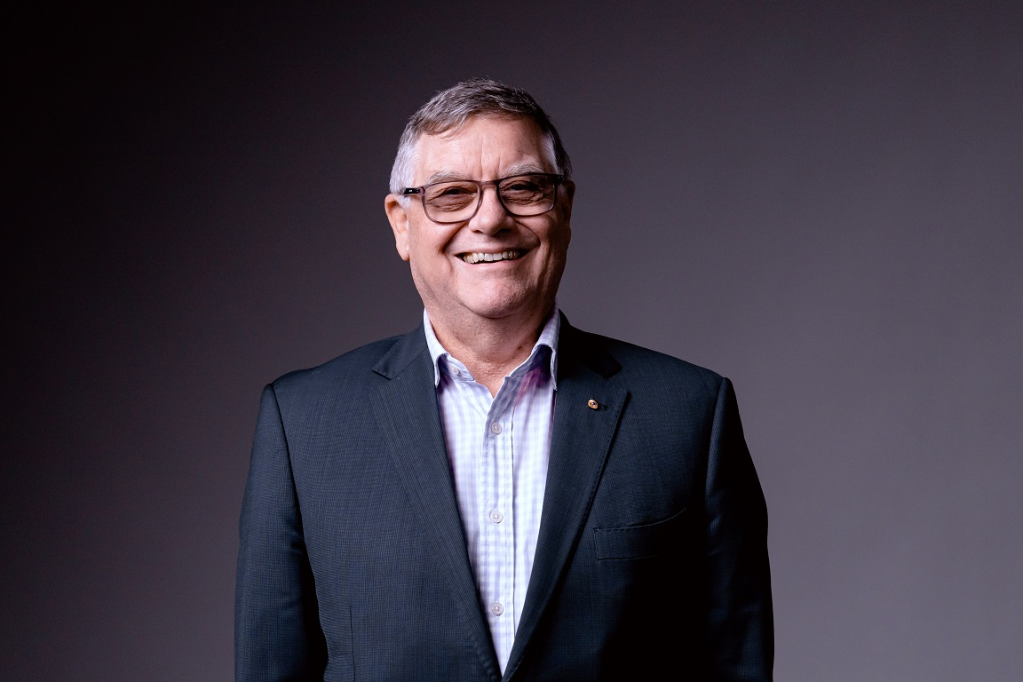

Chair

Appointed 15 February 2022

Greg was appointed chair of Victorian Veterans Council in February 2022. Greg is a part-time member of the Royal Australian Navy and holds the position of Senior Naval Officer Victoria. He brings a wealth of experience in the navy and the Department of Defence.

Greg joined the navy in January 1974, rising to the rank of Commodore in June 2016. He has worked as a Principal Warfare Officer in the Executive Branch, having completed many sea postings including exchange in *HMS Liverpool* and his two most successful commands, *HMAS Gladstone*, a Fremantle class patrol boat, and *HMAS Arunta*, an ANZAC class frigate.

He was awarded a Conspicuous Service Cross for his leadership role as Chief Staff Officer (Operations) Maritime Headquarters during Operation Falconer (Iraq 2) in 2003 and was appointed as a Member of the Order of Australia in the 2022 Queen’s Birthday Honours.

Greg also had a successful second career as a management consultant during a 10-year absence from the navy and has been a non-executive director on the board of the Australian National Veterans Arts Museum since 2017.

### Lieutenant Commander Pelagia Markogiannakis

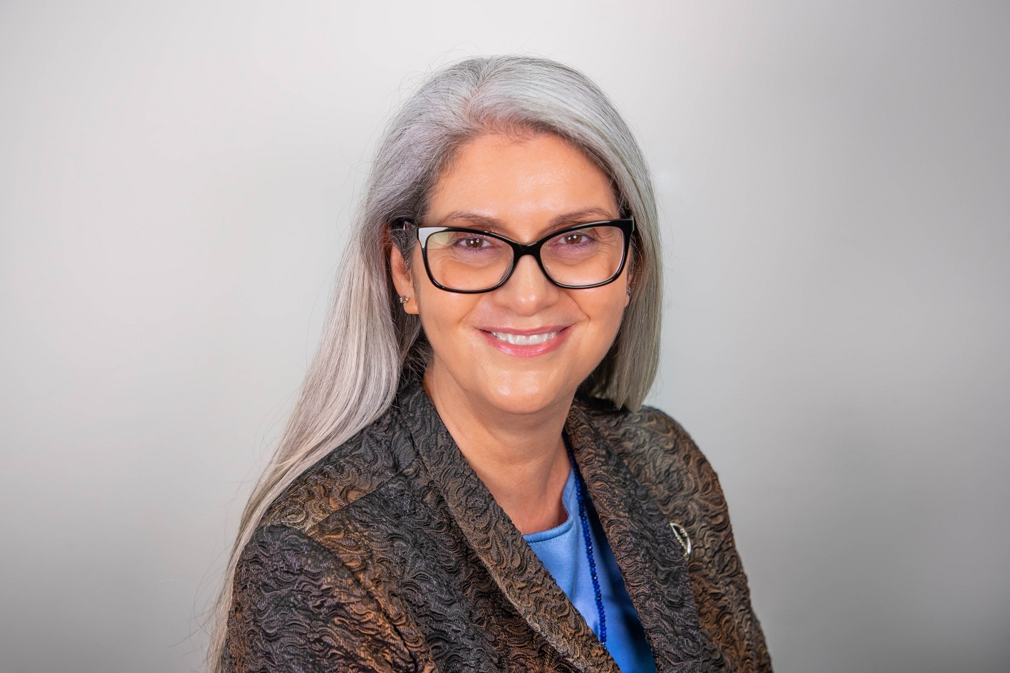

Deputy Chair

Appointed 6 February 2018

Appointed Deputy Chair 29 January 2020

Pela has been a navy reservist since 1986 and has attained the rank of Lieutenant Commander. She has had a variety of logistics, engineering and infrastructure-related roles.

Pela is an engineer and certified project professional. She has been the Aide-de-Camp in Waiting to His Excellency the Governor of New South Wales and the His Excellency the Administrator of the Commonwealth of Australia. She is currently serving as a reservist.

### Dan Cairnes

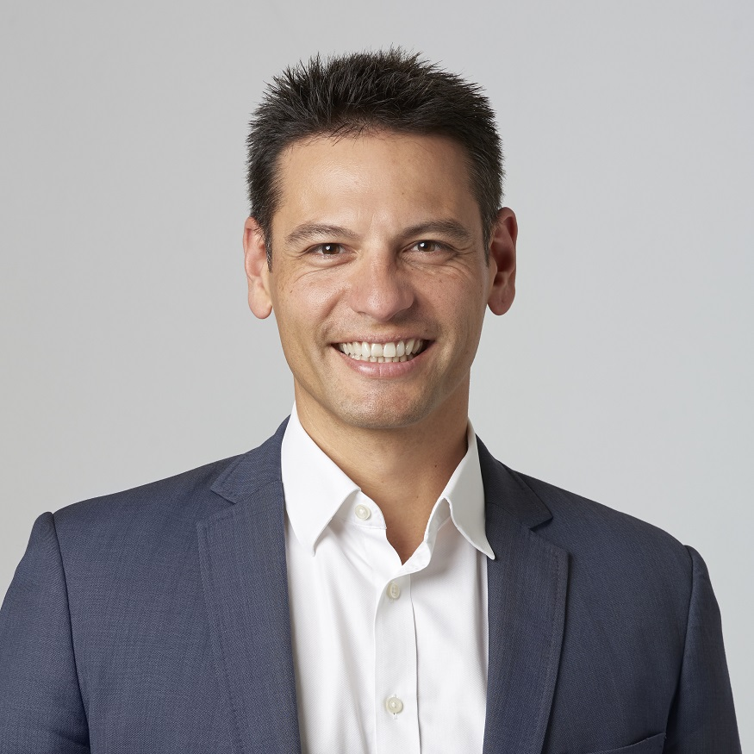

Appointed 8 June 2021

Dan served in the Australian Regular Army as an artillery officer where he fulfilled a range of regimental, operational and training appointments. The majority of his service was with the 8th/12th Regiment, Royal Australian Artillery.

His operational deployments include Iraq (Operation Catalyst) and border protection (Operation Relex II). On leaving the army, Dan entered the construction industry where he has worked in trade and management roles on building and infrastructure projects. Dan is a graduate of the Royal Military College, Duntroon and RMIT University.

### John McNeill

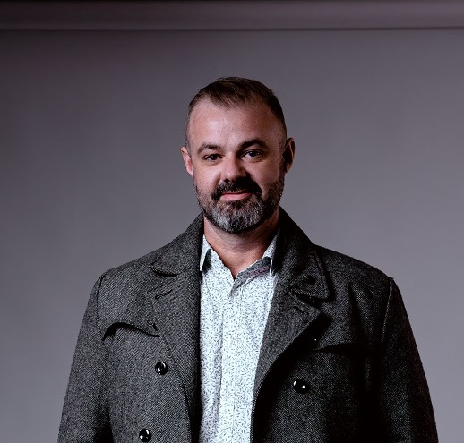

Appointed 3 November 2021

John has had extensive involvement in the veteran family advocacy and support space for the past 10 years as a qualified advocate. He served as a rifleman with the First Battalion and served in East Timor in 2007.

John has battled his own medical constraints post service and now supports others needing assistance throughout Australia to help them transition after service.

John holds positions on state and national boards such as the Deputy Commissioner’s Forum and the Operational Working Party. He is also a Level 3 Compensation Advocate with the Victorian Veterans Advocacy Centre.

John’s extensive involvement extends further by being the director of a social enterprise – Aussie Veterans Pty Ltd – established in Melbourne in 2017.

### Bruce Mildenhall

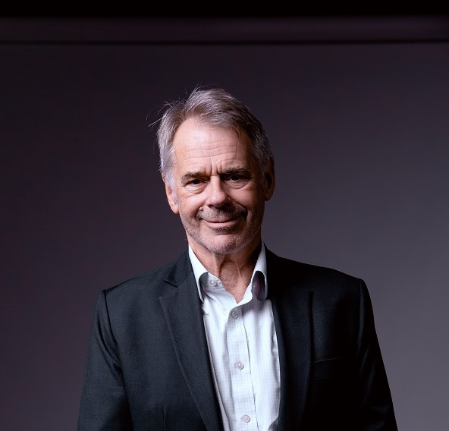

Appointed 7 August 2018

Bruce is not a veteran but has broad experience and strong personal interest in the veteran sector. He is currently involved in commemorative activities as chair of the Mt Macedon ANZAC Dawn Service and has assisted as support rider in the Vietnam Veteran Vetride. Bruce’s father was a Rat of Tobruk and his maternal grandfather an officer in the ANZAC Light Horse.

As a former State MP and Parliamentary Secretary for Veterans’ Affairs, Bruce helped draft Victoria’s veterans’ legislation, the Veterans Act 2005, and led the first Premier’s Spirit of Anzac Prize tour to the Western Front.

### Jo-Anne O’Brien



Appointed 17 May 2022

Jo-Anne is a member of the ex-service community as a surviving partner and widow of a veteran. She has significant knowledge and lived experience of veterans’ welfare and the needs of veterans’ surviving partners and families. Jo-Anne was nominated to become a member of the VVC by Warrnambool Legacy Club.

In addition to her knowledge of veterans’ welfare issues, Jo-Anne brings to the VVC significant experience working in the community and local government sectors relating to tourism and economic and community development, as well as a number of volunteer roles including with Rotary and the Country Fire Authority.

### Lucy Saaroni



Appointed 8 February 2022

Lucy is a risk management professional and a veteran with a passion for community resilience building.

As a public affairs officer with the Australian Army, Lucy has deployed on warlike military operations in Afghanistan and Iraq and has also supported politico-military missions in the Gulf States and North West Africa.

Working in the Office of the Defence Attaché at the Australian Embassy in France between 2008 and 2013, Lucy had the privilege of supporting large-scale multinational military commemorative ceremonies including the reburial of 250 Australian and British World War One soldiers at the Fromelles Military Cemetery and planning the ANZAC Centenary Commemorations in France.

In 2018 Lucy was awarded the Australia Day Medallion for service to Defence and Indigenous Communities.

With qualifications and extensive experience in risk management, strategic communications and community engagement, Lucy has held senior advisory and executive management roles in local and state government.

### Simon Thorn

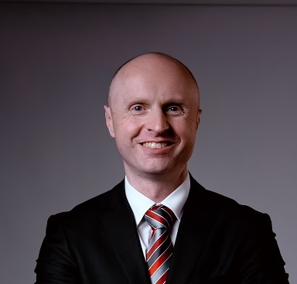

Appointed 20 September 2022

Simon is a former commissioned Australian Regular Army Officer who served in a wide variety of operational roles including in Iraq and Afghanistan. Since leaving Defence, he has held senior roles at the Office of Police Integrity and the Independent Broad-based Anti-corruption Commission. He has been the senior executive responsible for regulating the apprenticeship and vocational education and training (VET) sectors in Victoria and was a senior executive with the Commonwealth VET regulator. Simon is currently working as a consultant.

Simon is a State Executive member of the Victorian Returned and Services League, where he chairs the Risk, Audit and Governance Committee. He is passionate about ensuring veterans are supported through sound policy and that ex-service organisations are supported to deliver in an ever-changing environment.

He holds a Bachelor of Science from the University of New South Wales, a Master of Business Administration from Latrobe University, is a graduate member of the Australian Institute of Company Directors and an ANZSOG Executive Fellow.

### Ken Tsirigotis

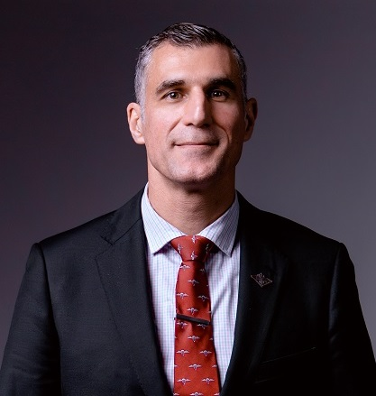

Appointed 25 August 2020

Ken completed 22 years of service in the Australian Regular Army in the Royal Australian Infantry Corps with the majority of his service as a reconnaissance soldier at the 3rd Battalion, The Royal Australian Regiment (Parachute). His overseas service has included exchanges and regimental duties to Indonesia, New Zealand, France, Belgium, Thailand, the UK and Switzerland.

Operational experiences include International Forces East Timor (1999–2000), United Nations Transitional Authority East Timor (2002), Timor-Leste Battle Group Three as part of the Ready Company Group deployment (2008), Timor-Leste Battle Group Four (2008) and Operation Slipper as a Mobile Mentoring Team Commander in the Uruzgan Province Afghanistan (2012).

Ken has been awarded various Australian Defence Force (ADF) awards including the Soldiers Medallion for Exemplary Service, Commander 1st Division Commendation (Bronze), Deputy Chief of Joint Operations Commendation (Bronze) and ADF Commendation (Silver).

Ken transferred from the Australian Regular Army in 2016 taking up employment with Melbourne Legacy and has held various roles, most recently as the Chief Operating Officer where he manages the engagement supporting service delivery operations of the organisation.

### Brett West

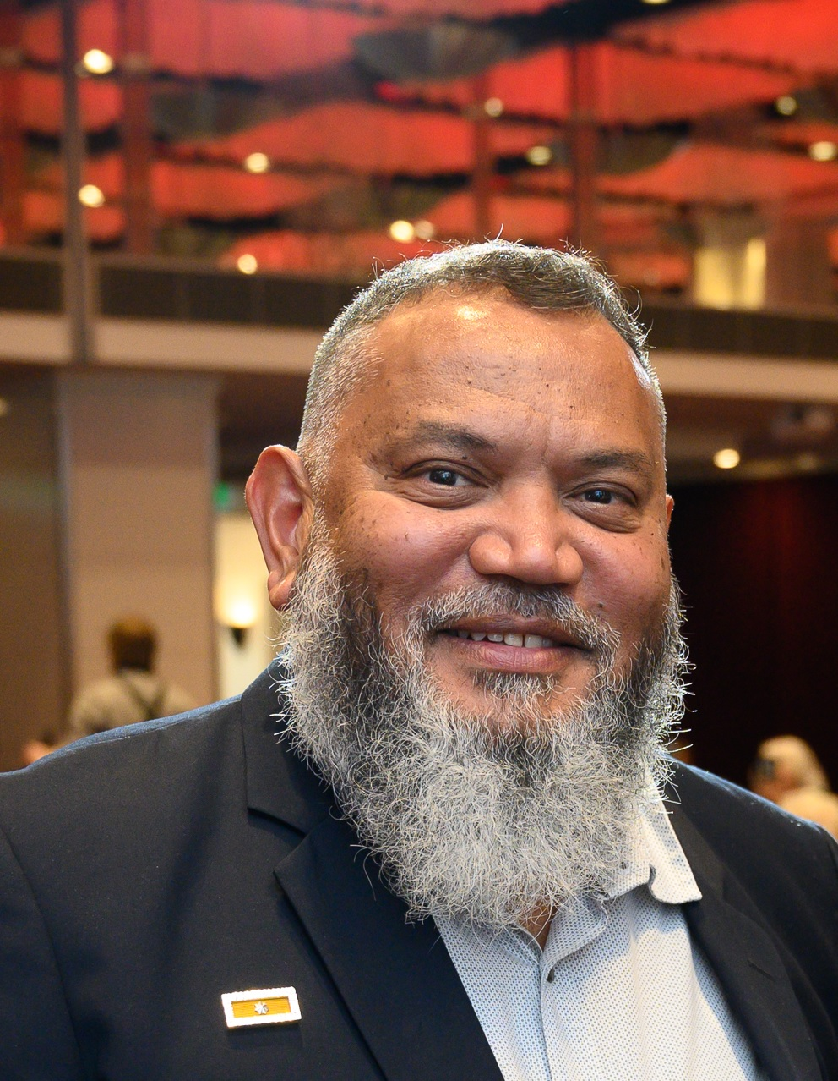

Appointed 20 September 2022

Brett is a Yamatji man and veteran of the ADF, serving 30 years with the Royal Australian Air Force including operational service and tours in the Middle East.

Brett’s roles in the ADF related to ordnance safety, training and maintenance and explosive ordnance disposal, as well as later roles on policies and programs relating to Indigenous recruitment and retention, community engagement and mentoring.

Since leaving the ADF in 2017, Brett has worked with the Victorian Government’s Department of Education in roles focusing on Aboriginal and Torres Strait Islander education and training.

Brett was appointed to the VVC in 2022 and is a member of the Aboriginal and Torres Strait Islander Veterans and Services Association.

### Glen Ferrarotto

Member from 7 December 2021 to 19 September 2022.

### Anita Hogan

Member from 24 March 2020 to 23 March 2023.

# Highlights of the year

## Engagement with the ex-service community

Throughout the year, the VVC continued its engagement with the veteran community and with ex-service organisations. The VVC received regular updates from ex-service organisations, such as the Returned & Services League of Australia (Victorian Branch) (RSL Victoria) and Melbourne Legacy through its representatives on the VVC.

The VVC also met with its stakeholders, including:

* visiting Austin Health’s Ward 17 and taking part in Austin Health’s Veterans Consultative Group
* taking part in a Department of Health roundtable on Victoria’s new suicide prevention and response strategy in response to the Royal Commission into Victoria’s Mental Health System
* taking part in consultation roundtables on implementing the Veterans Card Victoria
* meeting with members of the Queensland Veterans’ Council
* taking part in a panel discussion during the Queensland Veterans’ Council inaugural planning session.

The VVC also met with and heard presentations from:

* Victoria’s Veteran Employment Advocate Major General David McLachlan AO AO (Mil) (Retd) and Ray Cadmore (Jobs Victoria) on Victoria’s veteran employment programs
* RSL Victoria’s Chief of Veteran Services Ben Webb
* Melbourne Legacy’s Annabelle Wilson on the Victorian Veterans Family Services program, which provided support to families during the Royal Commission into Defence and Veteran Suicide.

Members of the VVC also met with staff from the Royal Commission into Defence and Veteran Suicide and took part in national ESO forums hosted by RSL Australia.

Bruce Mildenhall attended and presented scholarships for the Australian Nurses Memorial Centre, which the VVC supports as a patriotic fund trustee.

|  |
| --- |
| VVC member Brett West addresses the Premier’s Anniversary of Anzac Day State Luncheon; |
| Caption: VVC member Brett West addresses the Premier’s Anniversary of Anzac Day State Luncheon. |

## Victorian Veterans Sector Study 2022

At the request of the Minister for Veterans, the VVC commissioned its third Victorian Veterans Sector Study in 2022, following on from previous studies in 2008 and 2015. The 2022 study focused on:

* veteran housing and homelessness
* veteran mental health and suicide
* veteran employment and education
* the impact of COVID-19 on the veteran sector and the organisations supporting our ex-service community.

In 2022–23 the VVC considered the findings and presented the study along with the VVC’s recommendations to the Victorian Government. Through its 2023 work plan the VVC started:

* responding to areas of concern noted by the study, including the inconsistency of definitions of ‘veteran’ across Australian states and territories
* exploring setting up a community of practice for veteran advocates and welfare officers to share knowledge and experience.

## ESO Summit 2022

|  |
| --- |
| Joel Sardi addresses the ESO Summit  Caption: Joel Sardi addresses the ESO Summit. Photo: Nico Keenan, Nico Photography. |
| Vasey RSL Care at the ESO Summit  Caption: Vasey RSL Care at the ESO Summit. Photo: Nico Keenan, Nico Photography. |
| Austin Health Veteran Liaison at the ESO Summit  Caption: Austin Health veteran liaison at the ESO Summit. Photo: Nico Keenan, Nico Photography. |
| Guitars 4 Vets Australia (G4VA) at the ESO Summit |
| Caption: Guitars 4 Vets Australia (G4VA) at the ESO Summit. Photo: Nico Keenan, Nico Photography. |

Held on 6 August 2022, the inaugural ESO Summit was designed to promote collaboration and cooperation between the organisations that support Victoria’s veteran community. The summit was well attended, with 250 people taking part in person and online. Held under the theme ‘participate, discover, connect’, the ESO Summit featured keynote speakers including the former Minister for Veterans the Hon Shaun Leane MP and veteran Joel Sardi. There were also masterclasses, information sessions, showcases and panel discussions.

## Commemoration and ANZAC Day services

The VVC supports ANZAC Day and other commemorations and events in local communities through funds from the Victorian Veterans Fund. This funding is distributed under the Victoria Remembers Grant Program.

This year VVC members attended services, commemorations and events across Victoria. These included the openings of the Sir John Monash water tower mural and the ‘Changed Forever’ exhibition in Charlton, and the opening of the ‘Remembering Vivian Bullwinkel at Devenish Silos’ project delivered by the Australian Nurses Memorial Centre. The VVC supported these projects through the Victoria Remembers Grant Program. The VVC also attended the Premier’s Anniversary of Anzac Day State Luncheon, as well as services including:

* RSL Victoria’s Springvale War Cemetery Remembrance Service
* the City of Port Phillip’s Remembrance Service
* the Bombing of Darwin Commemorative Service.

## Victoria Remembers Grant Program highlights

The VVC, through the Victoria Remembers Grant Program, is proud to support community projects that promote a better understanding of the service and sacrifice of Victoria’s veterans in war and peacekeeping operations. It also commemorates those who have died in the performance of service or duty. A complete list of grants awarded in 2022–23 is available in the Victorian Veterans Fund section.

### Promoting education and understanding

The Victorian Remembers Grant Program supports projects that educate about and enhance understanding of the participation of Victorians in war and peacekeeping operations. This year, projects supported included:

* $30,000 to the Shrine of Remembrance to deliver an exhibition featuring the stories of Forces Entertainment veterans and entertainers
* $15,000 to Musicult Inc. in partnership with Friends of Gallipoli Inc. to present a Gallipoli Remembrance concert from both Australian and Turkish perspectives featuring music in English and Turkish
* just over $20,000 to the Museum of Chinese Australian History for its project to publish stories and interviews of Chinese Australians who served in the First and Second World Wars
* more than $23,000 to Caroline Springs RSL to produce a documentary about Caroline Springs RSL including the stories of its veterans and volunteers and its contribution to the local community, with a focus on its commemorative services, veteran welfare team and its school education program.

### Supporting commemoration and remembrance

The Victoria Remembers Grant Program supports the community to recognise the service and sacrifice of Victoria’s veterans. This year, services and commemorative events supported through the Victoria Remembers Grant Program included:

* the Battle for Australia Commemoration Ceremony
* ANZAC Day services in the Borough of Queenscliffe
* support for regional students to attend the annual ANZAC Schools ceremony at the Shrine of Remembrance
* the 81st anniversary of the Bombing of Darwin in 1942
* support for Melbourne Legacy’s 91st ANZAC Commemoration Ceremony for Students
* the Mt Macedon ANZAC Day Dawn Service
* the Boer War Day Commemoration Parade and Service
* a commemorative event for the Battle of Kalamata in honour of Australians and Greeks who fought in Greece in World War Two.

### Supporting the preservation of Victoria’s wartime heritage

This year, wartime heritage projects supported by the Victoria Remembers Grant Program included:

* funding for the Shrine of Remembrance to preserve and display the Grimwade sea-chest and bell, as well as 13 handwritten diaries
* funding for new display cabinets for Seymour RSL Sub-branch to improve the accessibility of its collection
* more than $28,000 to preserve the wartime heritage of the *Alma Doepel*[1]
* funding of $30,000 was also provided for the Trafalgar Holden Museum to restore and display its Wackett trainer aircraft, the first Australian-designed aircraft to see major service in the Royal Australian Air Force during World War Two.

The VVC is proud to support the preservation of Victoria’s wartime heritage and looks forward to the successful completion of these projects.

## ANZAC Day Proceeds Fund Grant Program highlights

Through the ANZAC Day Proceeds Fund Grant Program, the VVC is proud to support the welfare activities of Victoria’s ex-service organisations. A complete list of grants awarded in 2022–23 is available in the ANZAC Day Proceeds Fund section.

Some of the recent initiatives and activities supported by the VVC in 2022–23 include:

* more than $66,000 to support Aussie Veterans Social Programs to help veterans and their families make new social connections and friendships, take part in physical activities and connect with service providers and support networks
* $150,000 to Carry On (Victoria) to continue its crisis accommodation pilot program and to provide direct welfare support to veterans and their families
* $150,000 to Soldier On for its Vet Connect Victoria program to support ADF members in the process of transitioning from service
* $50,000 to Melbourne Legacy for its Education, Upskilling and Training project to support families of veterans to achieve their academic and career goals and build a better future for themselves post-service
* $30,000 to VetRide for its ‘Ride ANZAC’ event to support veterans to take part in a three-day cycling event to help build social connections.

# Corporate governance

## Council meetings

The Veterans Act requires that the VVC must meet at least eight times each year. The VVC held eight meetings during the period between 1 July 2022 and 30 June 2023.

## Committee structure

The VVC has established two permanent committees to help fulfil its functions under the Act. It also formed working parties to oversee items of work including:

* an Engagement Strategy Working Group
* a Veteran Definitions Working Group
* a Communities of Practice Working Group.

### Funding Sub-Committee

The Funding Sub-Committee develops and reviews the grant guidelines for the Victorian Veterans Fund and the ANZAC Day Proceeds Fund. It assesses applications for both funds and makes funding recommendations to the VVC for grants from both funds. During the year the Funding Sub-Committee reviewed and updated its charter and the guidelines for the ANZAC Day Proceeds Fund grant program.

Dan Cairnes chaired the Funding Sub-Committee in 2022–23. The other members of the sub-committee were John McNeill to 5 September 2022, and Lucy Saaroni, Jo-Anne O’Brien and Brett West from 14 October 2022. The Funding Sub-Committee met twice during the year.

### Governance Sub-Committee

The Governance Sub-Committee ensures the VVC complies with all financial and legal requirements under the Act and any other relevant legislation. The sub-committee is also responsible for governance of the six patriotic funds for which the VVC is trustee. It also develops the VVC annual report.

Bruce Mildenhall chaired the Governance Sub-Committee in 2022–23. Other members were Pela Markogiannakis, Ken Tsirigotis and Simon Thorn (from 14 October 2022), and John McNeill (from 14 October 2022).

The Governance Sub-Committee met once during the year to oversee VVC’s administration of patriotic funds and associated investment accounts. A second meeting was scheduled but was postponed and held in the following financial year on 5 July 2023. During the year the sub-committee reviewed the VVC’s risk management framework, considered standardised reporting from RSL Victoria and Melbourne Legacy to the VVC, and matters relating to administering patriotic funds for which the VVC is a trustee.

### Secretariat support

The Office for Veterans in the Department of Families, Fairness and Housing provided secretariat support to the VVC and its sub-committees.

## Audited financial records

The VVC financial results are aggregated into the department’s financial statements, pursuant to a determination made by the Minister for Finance under s 53(1)(b) of the **Financial Management Act 1994**. Financial statements can be found on the [department’s website](https://www.dffh.vic.gov.au/publications/annual-reports) <https://www.dffh.vic.gov.au/publications/annual-reports>.

On 6 September 2018 the VVC applied to the Minister for Finance seeking a full exemption from the Standing Directions of the Minister for Finance under the Financial Management Act. On 1 October 2018 the Minister for Finance approved this application, exempting the VVC on an ongoing basis from complying with requirements of the Standing Directions.

# ANZAC Day Proceeds Fund

The ANZAC Day Proceeds Fund receives contributions from sporting events held on ANZAC Day across Victoria. These are collected by Sport and Recreation Victoria in the Department of Jobs, Precincts and Regions, in keeping with s 4A of the ANZAC Day Act.

In 2022–23 grants totalling $806,251.42 were approved from the ANZAC Day Proceeds Fund to 22 projects. The following table details the grant recipients.

## ANZAC Day Proceeds Fund 2022–23 approved grants

| Organisation | Project | Amount |
| --- | --- | --- |
| Air Force Association – Victoria | Veterans’ Welfare Program | $15,000.00 |
| Aussie Veterans Pty Ltd | Aussie Veterans Social Programs Season 2 | $66,990.00 |
| Australian Peacekeeper & Peacemaker Veterans’ Association | Victoria Welfare Support | $20,000.00 |
| Bendigo Legacy Club | Heating Allowance for Beneficiaries of Bendigo Legacy | $5,590.00 |
| Carry On (Victoria) | Well-being Support to Veterans and their dependants | $150,000.00 |
| Flemington/Kensington RSL Sub-Branch Patriotic Fund | Member Welfare Outreach Program | $10,000.00 |
| Gisborne Macedon Ranges RSL Sub-Branch | Welfare lunches | $9,000.00 |
| Goorambat Veterans' Retreat Incorporated | Veterans and Families of Veterans Outreach, Connection & Re-connection Program | $25,000.00 |
| Macedon Ranges Group of Bendigo Legacy | Heating support to Legacy Widows | $6,000.00 |
| Melbourne Legacy | Legacy Youth Wellbeing Support Camps Program | $50,000.00 |
| Melbourne Legacy | Legacy Education, Upskilling and Training Program | $50,000.00 |
| Returned & Services League of Australia (Victorian Branch) Inc | RSL Victoria General Appeal – welfare support | $62,675.00 |
| Soldier On Limited | Soldier On Vet Connect Victoria for Veterans & Families | $150,000.00 |
| South Gippsland Group of Melbourne Legacy Inc | Winter Fuel | $7,200.00 |
| The Legacy Club of Ballarat Inc. | 2023 Winter Heating Allowance | $19,500.00 |
| Totally & Permanently Incapacitated Ex-Servicemen and Women’s Association of Victoria Inc. | Defibrillators and First Aid Kits for TPI Victoria Inc. | $12,536.00 |
| Vasey RSL Care Limited | Welfare Support Funding for Veterans and Widows in Need | $50,000.00 |
| Veteran Housing Australia Pty Ltd | Housing the Homeless Veteran | $31,819.00 |
| VetRide Incorporated | Ride ANZAC | $30,000.00 |
| Vietnam Veterans Federation Victorian Branch Incorporated | VVF VIC Branch Inc Welfare | $10,000.00 |
| Warragul RSL Sub Branch Incorporated Inc. | Veterans Respite and Retreat Program | $8,941.42 |
| Wimmera Veterans Centre | Connect-A-Vet | $16,000.00 |
| **Total ANZAC Day Proceeds Fund** |  | **$806,251.42** |

# Victorian Veterans Fund

The Victorian Veterans Fund was established under the Veterans Act. Revenue for the Community Support Fund is collected daily and distributed to community services annually. Revenue for the Veterans Fund for one financial year comes from the Community Support Fund and is equal to one day’s revenue of the Community Support Fund.

In 2022–23 funding of $100,000 for the Victorian Veterans Sector Study was provided through the Victorian Veterans Fund. Grants of up to $30,000 (excluding GST) are available for projects honouring or commemorating veterans’ service or educating Victorians about veterans’ contributions. Two funding rounds occur per year. In 2022–23 grants totalling $326,488.59 were approved for 26 projects. Funds were distributed under the Victoria Remembers Grant Program. The following table details the grant recipients.

## Victorian Veterans Fund 2022–23 grant recipients (Victoria Remembers Grant Program)

### **Round 1, 2022–23 funded projects**

| Organisation | Project | Amount |
| --- | --- | --- |
| Ararat Legacy Club Incorporated | Project Remembrance 2023 | $2,195.45 |
| Battle For Australia Foundation in Victoria | Battle for Australia Commemoration Ceremony | $10,000.00 |
| Boroondara City Council | Commemorating our Boroondara Victoria Cross Recipients | $8,730.00 |
| Borough of Queenscliffe | ANZAC Day services | $7,000.00 |
| Caroline Springs RSL Sub-Branch Inc. | Documentary Film – Stories of RSL Veterans and Volunteers | $23,900.00 |
| Darwin Defenders 1942–45 Melbourne Branch (Auspice) | Commemoration Service for the 81st Anniversary of the Bombing of Darwin in 1942 | $5,400.00 |
| Flemington/Kensington RSL  Sub-Branch Patriotic Fund | Honouring Local Servicemen | $12,500.00 |
| Melbourne Legacy | 91st Melbourne Legacy ANZAC Commemoration Ceremony for Students | $30,000.00 |
| Mount Macedon Memorial Cross Reserve Committee of Management (Auspice) | 2023 Mt Macedon ANZAC Day Dawn Service | $15,093.00 |
| Musicult Inc. | Gallipoli – Australian/Turkish Soldiers Perspective | $15,000.00 |
| Redcliffs/Irymple RSL Sub-Branch | Display Cabinet | $6,100.00 |
| Rotary Club of Monash Incorporated | ANZAC Service for Schools 2023 | $2,000.00 |
| Seville Primary School | Creation of WW2 Historical Plaque | $1,000.00 |
| Shrine of Remembrance Trustees | Forces Entertainment exhibition (working title) | $30,000.00 |
| Society Kalamata | Battle of Kalamata Commemoration | $1,500.00 |

### Round 2, 2022–23 funded projects

| Organisation | Project | Amount |
| --- | --- | --- |
| Boer War Association of Victoria | 2023 Boer War Day Commemoration Parade and Service | $2,900.00 |
| Bright RSL Sub-Branch | Remembering Bright’s Veteran Nurses | $1,328.14 |
| Friends of Gallipoli Inc. | 100Lone Pines website | $21,600.00 |
| Gippsland Grammar | Honouring our heroes – Gippsland Grammar remembers | $2,500.00 |
| Imvrians Society of Melbourne Inc. | Imbros & Gallipoli Revealed Exhibition Promotional Booklet | $4,157.00 |
| Museum of Chinese Australian History | Chinese Australian Veterans Project | $20,250.00 |
| Sail & Adventure Ltd | Victoria Remembers AK82 / *Alma Doepel* | $28,200.00 |
| Seymour RSL Sub-Branch | Display cabinets | $12,500.00 |
| Shrine of Remembrance | Shrine of Remembrance Collection access and display project | $27,135.00 |
| Trafalgar Holden Museum | Restoration and preservation of unarmoured Wackett trainer aircraft | $30,000.00 |
| Wesley College Melbourne | Commemorative plaque for Captain Robert Grieve VC | $5,500.00 |

### Rounds 1 and 2, 2022–23 funded projects total

|  |  |
| --- | --- |
| **Total Victorian Veterans Fund** | **$326,488.59** |

# Patriotic funds

The VVC, in partnership with Consumer Affairs Victoria as the regulator of patriotic funds, advises ex-service organisations on how patriotic funds can be raised and appropriately used, including transfer and winding-up arrangements.

The VVC is the trustee for six patriotic funds that are administered under Part 4 of the Veterans Act.

## The Australian Legion of Ex-Servicemen and Women Scholarship Fund – Albert Coates Memorial Trust

This fund, in association with the Albert Coates Memorial Trust, funds scholarships awarded to students who are studying to become paramedics, nurses or doctors in emergency care at Victorian universities. In 2022–23 the VVC provided $2,800 to the Albert Coates Memorial Trust to allocate scholarships for rural emergency nursing studies.

## The Australian Legion of Ex-Servicemen and Women Scholarship Fund No 1 – Nurses Memorial Centre

This fund was first established in August 2006. It supports scholarship grants awarded each year to students undertaking postgraduate studies caring for older people or palliative care at a recognised university. The VVC administers the funds, which are provided to the Australian Nurses Memorial Centre as the facilitator of the scholarships. In 2022–23 the VVC provided $2,960 to the centre for these scholarships.

## The War Widows and Widowed Mothers Association Scholarship Fund

This fund supports scholarships awarded by the Federation University Australia to students undertaking graduate or postgraduate study in the fields of nursing, palliative care, aged care or midwifery. In 2022–23 the VVC approved $2,000 for these scholarships.

## The Victorian Blinded Soldiers’ Welfare Patriotic Fund

This fund was established in April 2013 from funds provided by the Blinded Soldiers’ Association and a letter bequest from the estate of the late Lucy Adamson. It provides welfare assistance to visually impaired veterans and their dependants and offers assistance to former ADF members who have visual impairment due to their service.

## The Extremely Disabled Association Patriotic Fund

This fund supported the now discontinued Victorian Veteran Community Story Writing and Art Competition, which Austin Health’s Heidelberg Repatriation Hospital facilitated.

## Australian United Ex-Services Association Patriotic Fund

This fund was established in 2015 to help fund postgraduate study in the field of veterans’ health. A memorandum of understanding with Austin Health was signed in February 2016 to deliver the scholarships for training postgraduate students in cognitive processing therapy, with an associated year of supervision.

1. During World War Two the *Alma Doepel* was used as an Australian Army supply vessel. The funding supports refitting the crew quarters with period-appropriate fittings, memorabilia and interpretive panels and improving access to the public.